**Family Literacy Training Institute**

Yellowknife, NT

**September 14 – 18, 2015**

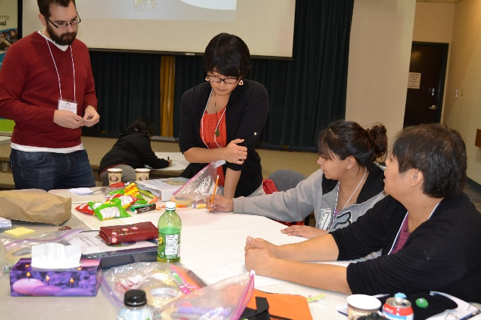 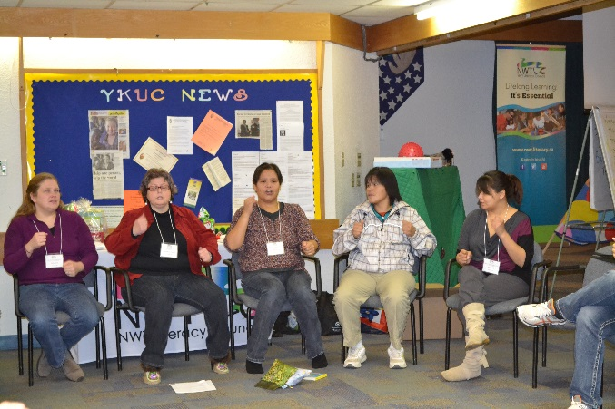

Sponsored by the

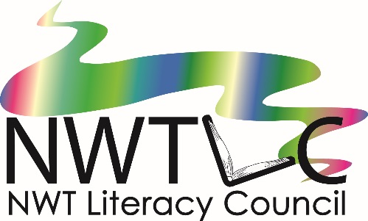

(867) 873-9262

1-866-599-6758

[nwtliteracy@nwtliteracy.ca](mailto:nwtliteracy@nwtliteracy.ca)

**Family Literacy Training Institute**

**Where? Northern United Place**

**When**? September 14-18, 2015

**Who should attend**?

|  |  |
| --- | --- |
| * Early Childhood Educators * Adult Educators * CPNP program staff * Teachers or Educational Assistants * Community Health Representatives (CHRs) * Family Literacy Coordinators | * Aboriginal Head Start program staff * Preschool Programs * Librarians * Anyone interested in Family Literacy |

**Workshop Overviews**

**Introduction to Family Literacy**

The Introduction to Family Literacy workshop will explore the meaning of family literacy…. how everyday activities such as cooking, making crafts and spending time together are literacy experiences for children. You will learn how to expand on these activities to incorporate them into your family literacy program.

**clip00131-2-3 Rhyme with Me**

*1-2-3 Rhyme with Me*is a fun, interactive rhyming and singing program for young children and their parents. Come and learn how to facilitate this program in your community. You will learn about brain development and oral language development, as well as many fun rhymes and songs to use in your program. You will receive a book and a CD of rhymes, stories and songs to take home.

**C:\Documents and Settings\staff\Local Settings\Temporary Internet Files\Content.IE5\O797IAV5\MCj02321280000[1].wmfChoosing Books**

The choosing books workshop will explore different types of books and why we love them! Participants will have the opportunity to share their favorite books with others. You will learn how to read with enthusiasm and have fun with reading. Get set for some fun, hands-on book exploration.

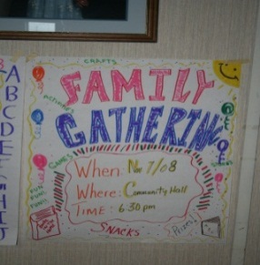**Family Literacy Nights**

Family literacy nights are a great way to get started in family literacy in your community. This session will explore different ideas for family literacy nights, and ways you can partner with others in your community.

**Storytime Adventures**

Storytime Adventures is a program for preschool children. Each session includes reading a story and doing a related craft, snack, game or other activity. After this workshop, you will be able to run a Storytime Adventures program in your community. You will receive a manual with ideas for 10 different Storytime Adventures to help you get started.

**Bookmaking**

The bookmaking workshop will show you how to make books for your program (great for Aboriginal languages) and also with participants in your program. You will learn how to make a variety of different books, using materials that are available in the NWT.

**Babies Are Born Learning**

We now know that the brain grows more in the first three years of life than at any other time.  This workshop explains the connection between early childhood experiences, brain development, and lifelong learning and well-being.  It will cover the basics of early childhood brain development, how children learn language, and how parents and caregivers can give the early care needed to build a strong foundation for life.

To register, email or fax this form to:

NWT Literacy Council

[nwtliteracy@nwtliteracy.ca](mailto:nwtliteracy@nwtliteracy.ca)

Fax: (867) 873-2176

Phone: (867) 873-9262 or toll free in the NWT: 1-866-599-6758

###### **Family Literacy Training Institute**

September 14-18, 2015

**Name** _______________________________________________________________

**Organization** _________________________________________________________

**Position or Job Title** ___________________________________________________

**Address** ____________________________________________**Postal Code**________________

**Phone** _____________________  **Fax** _____________________

**Email** _______________________________________

**Please tell us a little about yourself and your interest in family literacy:**

**_________________________________________________________________________**

**_________________________________________________________________________**

**_________________________________________________________________________**

_________________________________________________________________________

**Cost to register: FREE!**

**Do you require a travel subsidy? __________**

**Travel, accommodations and meals will be provided for ALL participants travelling from outside Yellowknife.**

**Registration is limited, so please register by September 1, 2015 to ensure your space!**

**Lunch will be provided for all participants each day during the training.**