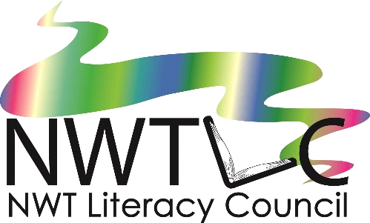Family Literacy
Training Institute
October 15-18, 2018

Registration Form

Name: | Organization:
Position or Job Title:
Address:
Postal Code:
Phone: | Fax:
Email:

Travel, accommodations, and meals will be provided for participants travelling from outside Yellowknife. Breakfast and lunch will be provided for all participants during the training.
Do you require a travel subsidy?
Do you have any special travel needs?
Do you have any food allergies?

Please tell us a little bit about yourself and your interest in Family Literacy:

To register, email or fax this form to:
NWT Literacy Council
nwtliteracy@nwtliteracy.ca
fax: (867) 873-2176

Registration is limited, so please apply early! Preference is given to applicants who haven’t attended before.

