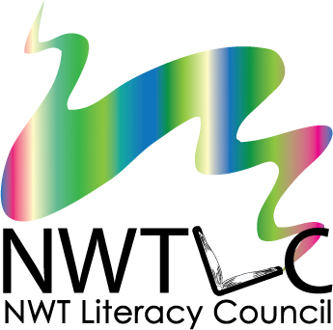
Skill Builders for Youth
Annual Training
Yellowknife, NT June 12-14, 2018
Registration Form

Name: | Organization:
Position or Job Title:
Address:
Postal Code:
Phone: | Fax:
Email:

Travel, accommodations, and meals will be provided for ALL participants travelling from outside Yellowknife. Breakfast and lunch will be provided for all participants during the training.
Do you require a travel subsidy? Choose yes or no
Do you have any food allergies? Choose yes or no
If yes, please describe:
Do you have any special travel arrangements? Choose yes or no
If yes, please describe:

Please tell us a little bit about yourself and your interest in youth literacy and essential skills:
__________________________________________________________________________________________________________________________________________________________________________________________________________________________________________________________________________________________________________________________________________________________________________________________________________________________

To register, email or fax this form to:
NWT Literacy Council
emily@nwtliteracy.ca
fax: (867) 873-2176

Please note that sending in this form does not guarantee your attendance. Registration is limited, and preference will be given to participants from communities who have not already taken part in this project.

