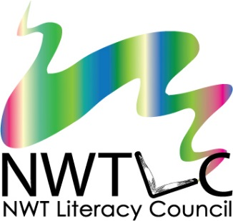
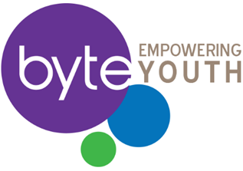
Facilitating for Youth
Yellowknife, NT March 27-28, 2019
Registration Form

Name: | Organization:
Position or Job Title:
Address:
Postal Code:
Phone: | Fax:
Email:

Travel, accommodations, and meals will be provided for ALL participants travelling from outside Yellowknife. Breakfast and lunch will be provided for all participants during the training.
Do you require a travel subsidy? Choose yes or no
Do you have any food allergies? Choose yes or no
If yes, please describe:
Do you have any special travel arrangements? Choose yes or no
If yes, please describe:

Please tell us a little bit about yourself and why you are interested in this workshop:
__________________________________________________________________________________________________________________________________________________________________________________________________________________________________________________________________________________________________________________________________________________________________________________________________________________________

To register, email or fax this form to:
NWT Literacy Council
emily@nwtliteracy.ca
fax: (867) 873-2176

The deadline to register is 5pm on March 13th, 2019.
Please note that sending in this form does not guarantee your attendance. Registration is limited, and application will be processed based on regional representation and the order in which they are received.

