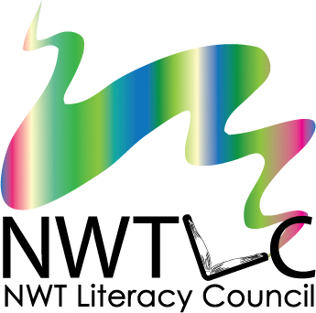
Skill Builders for Youth
Annual Training
Yellowknife, NT May 14-16, 2019
Application Form

Name: | Organization:
Position or Job Title:
Address:
Postal Code:
Phone: | Cell:
Email:

Travel, accommodations, and meals will be provided for ALL participants travelling from outside Yellowknife. Breakfast and lunch will be provided for all participants during the training.
Do you require a travel subsidy? Choose yes or no
Do you have any food allergies, sensitivities, or requests? Choose yes or no
If yes, please describe:
Would you like to request any special travel arrangements? Choose yes or no
If yes, please describe:

Please tell us a little bit about yourself and your interest in youth literacy and essential skills:
__________________________________________________________________________________________________________________________________________________________________________________________________________________________________________________________________________________________________________________________________________________________________________________________________________________________

To apply, email or fax this form to:
emily@nwtliteracy.ca
fax: (867) 873-2176
The deadline to apply is April 26th at 5pm

Please note that sending in this form does not guarantee your attendance. Registration is limited, and preference will be given to participants from communities who have not already taken part in this project.

