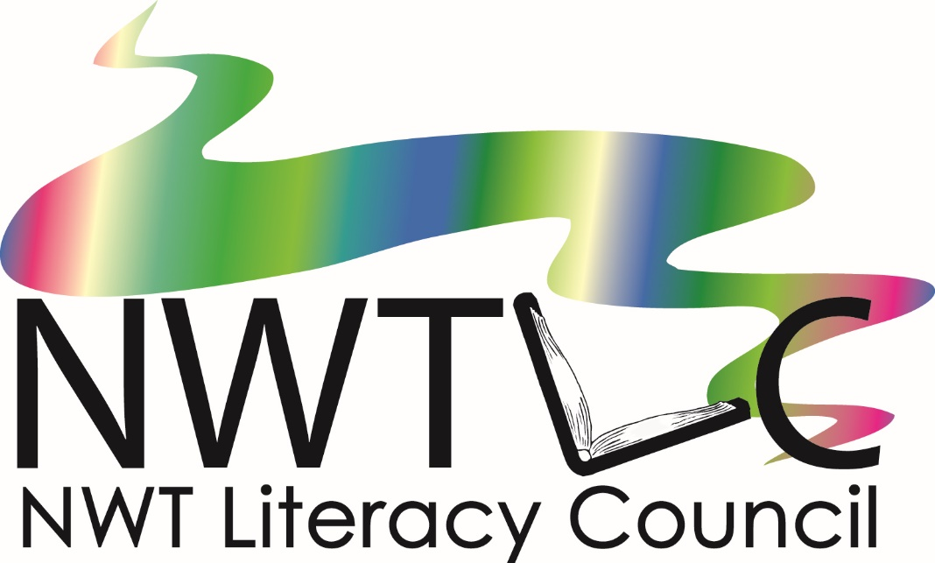  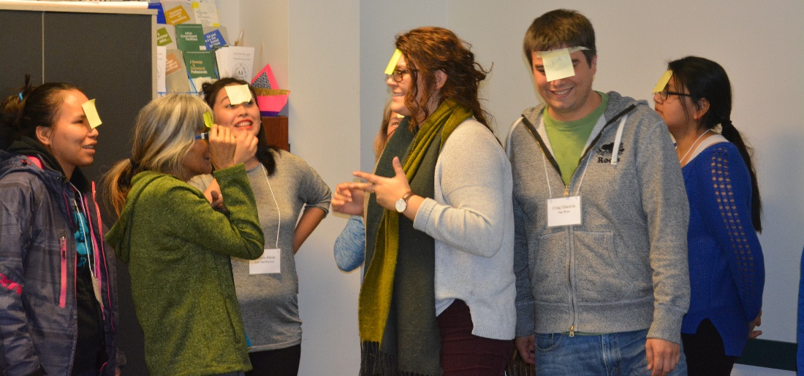  November 30  December 1, 7, & 8, 2020  Skill Builders for Youth Annual Training  Online Zoom Sessions  An annual training for Recreation Coordinators, Adult Educators, Teachers or Educational Assistants, Community Health Representatives (CHRs), Youth Centre program staff, Wellness Coordinators, Librarians, or anyone interested in youth literacy and essential skills! |  | Learn about literacy and essentials skills (LES)  Learn how to facilitate youth programs with embedded LES  Cost to register – free!  Registration is limited – apply by November 26, 2020!  NWT Literacy Council  PO Box 761,  Yellowknife, NT  X1A 2N6  coleen@nwtliteracy.ca  Phone: (867) 873-9262  Fax: (867) 873-2176  Toll Free: 1(866) 599-6758  www.nwtliteracy.ca
Training will include:
What are Literacy and Essential Skills (LES)?
An overview of what LES includes, and how to help youth develop their skills through programming that interests them.

Learning in the Kitchen: An interactive program, using cooking to develop LES. Participants will learn how to facilitate a program that helps youth learn to cook healthy meals, while having fun and learning LES as well.

Telling Our Stories: A technology based, digital story-telling program. Participants will learn how to lead youth in creating their own digital stories, while helping them to develop their computer use and other essential skills.

Youth Literacy Nights: A series of stand-alone activities that can be done at drop-in youth events. Participants will learn how to use short events to develop LES in youth.

Facilitation Skills: Participants will practice facilitation skills techniques, gaining confidence in facilitating a program.

Evaluation Skills: Evaluating a program is very important for improving it, and for future projects. Participants will learn techniques for evaluating their own projects, and the evaluation expectations for the Skill Builders for Youth project.

Program Planning: Participants will learn how to plan, promote and track their project. As a pair, participants will choose which project they would like to do in their community, and begin to plan it. After the training, pairs will have support from NWTLC staff to complete their planning.

Participants should come prepared with:
- An idea of which project they would like to do (Learning in the Kitchen, Telling our Stories, or Youth Literacy Nights).
- A community group who will support the project. This group will need to:
  - Receive and handle funds
  - Report to NWTLC at the end of the project
  - Possibly provide administrative support/ project space/ equipment as required by the different projects
- Potential community support for a youth literacy and essential skills project. Examples:
  - Elders who will provide guidance
  - Library will offer project space
  - School can offer computer lab access
- A personal commitment to lead a youth literacy and essential skills project, completing it by March 31st, 2021.

