How did you celebrate NWT Literacy Week 2015?
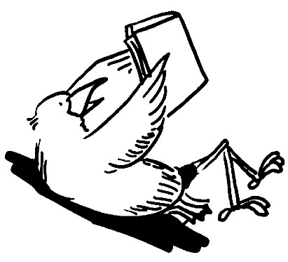
Tell us how you celebrated NWT Literacy Week 2015. We’re always interested in your ideas!
Community: _________________________
Name/Organization: _________________________
Address: _________________________
Phone: _________________________
Email: _________________________
Did you do any special activities for NWT Literacy Week? Please describe them. ________________________________________________________________________________________________________________________________________________________________________________________________________________________________________________________________________________________________________
How many people attended? _____
Did you use the NWT Literacy Week package? Why or why not? ____________________________________________________________________________________________________________________________________________________
How could we improve the package for next year? ______________________________________________________________________________________________________________________________________________________________________________________________________________________________
Do you have any suggestions for future resources? __________________________________________________________________________
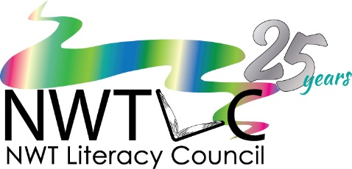

Thank you for filling in this questionnaire. Please return it by fax to (867) 873 2176 or by email to nwtliteracy@nwtliteracy.ca. Any photos of your events would be great too!
Please let people know before emailing the photos to us.

