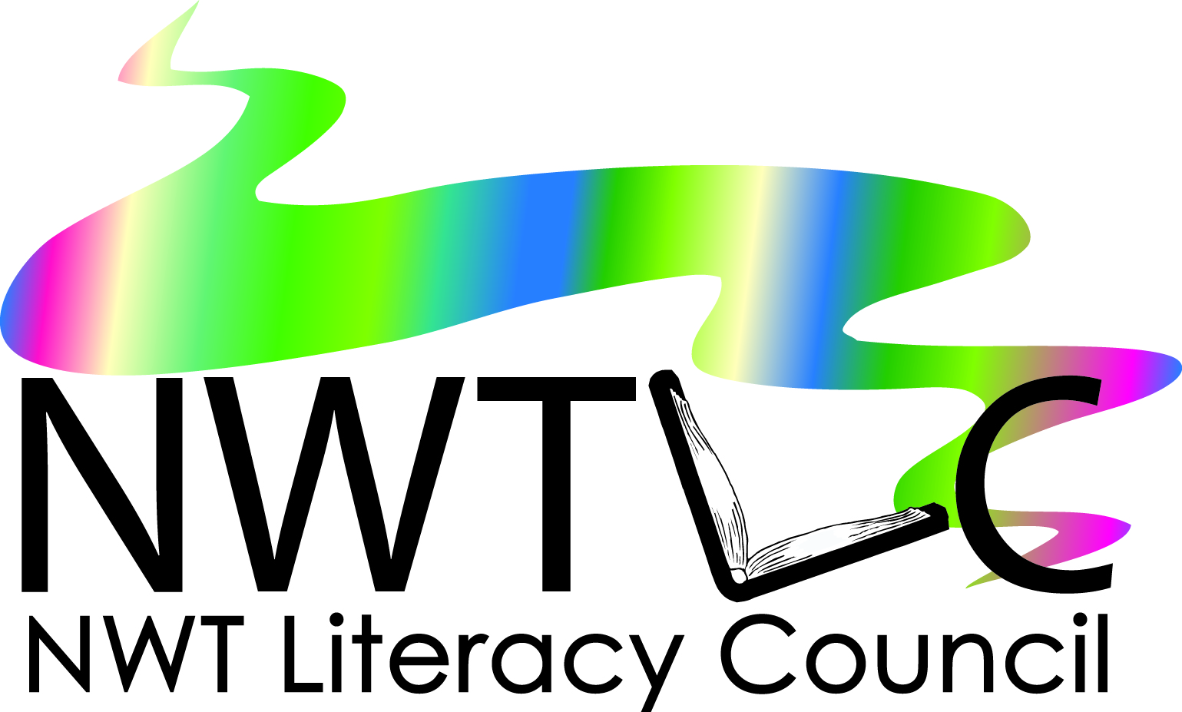
Proposal Writing Workshop
Registration Form

Dates: Tuesday and Wednesday, January 28 and 29
Time: 9 – 4 pm
Where: Fort Good Hope
Location: K'asho Got'ine Charter Community
Name: _______________________________________________________________________
Mailing Address: _____________________________________________________________
Email: _______________________________________________________________________
Phone #: _____________________________________________________________________
Organization: ________________________________________________________________
Please fax to the NWT Literacy Council at (867) 873-2176.
Or you can email nwtliteracy@nwtliteracy.ca and tell us you want to sign up for the workshop. Make sure you include all the information above.

It’s FREE

