Ideas for Family Literacy Day

- 2019 is the International Year of Indigenous Languages. See how many books you can read from our Books for Children by Indigenous Authors poster.

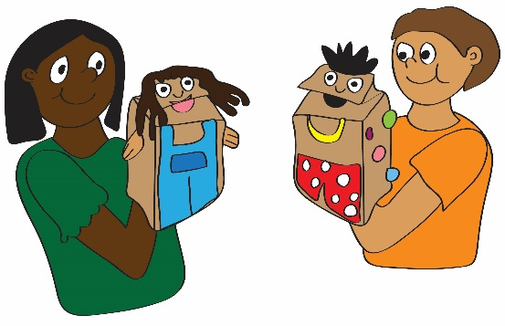
- Organize a Book Swap. Have families bring in their old books and swap them for books they have not read.

- Make some Fizzy Dough, Window Paint, Hot Chocolate Cloud Dough or another recipe in our 25 More Recipes for Fun resource.

- Take a look at On The Right Track, Building Aboriginal Literacy: Share Your Language, Share Your Culture and Love Grows Brains. These resources are translated into all 11 official languages of the Northwest Territories.

- Host a celebration in your community. You can have different games, crafts and activities that families can do together. Have food and prizes or draws for those who attend.

- Organize a read-a-thon at the library or school. Give out prizes and have lots of snacks.

- Cook a meal as a family. Pick out a favourite family recipe and work together to find your ingredients, follow the steps and cook your meal! There something that family members of all ages can do to contribute in the kitchen. Check out our Everyone in the Kitchen resource for tips and family friendly recipes!

Go to our website www.nwtliteracy.ca for the resources mentioned above as well as additional ideas and How-to-Kits.
Contact us for free books if you are hosting an event for Family Literacy Day 2019!

