Learn about the family literacy approach and how to facilitate family
literacy programs.

Cost to register – free!

Travel,
accommodations,
and meals provided
for all participants travelling from
outside Yellowknife.

Registration is limited, so apply early!

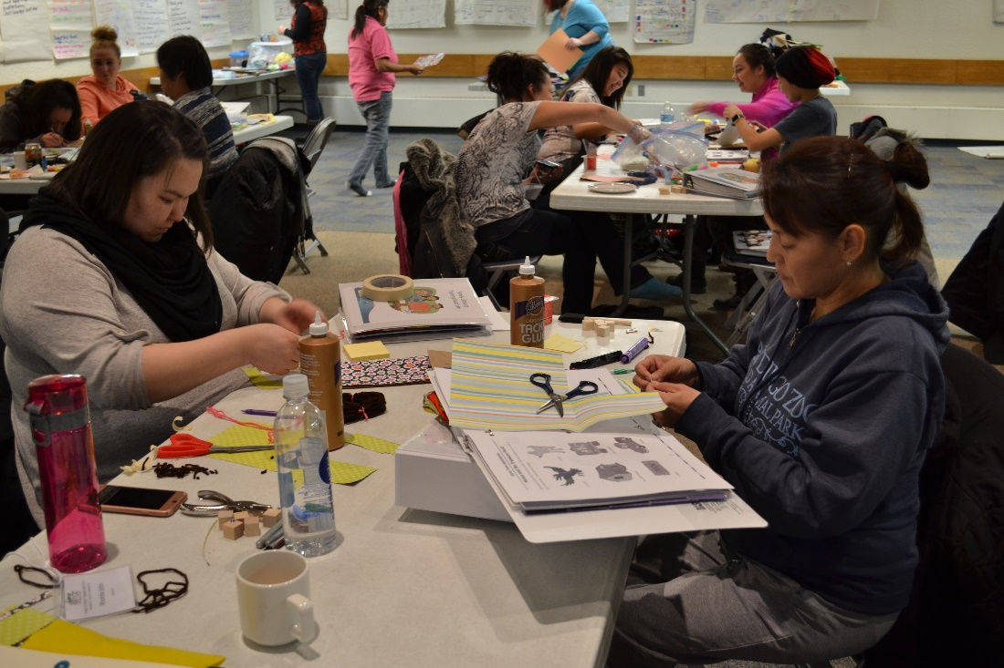
October 15–18, 2018
NWT Literacy Council
Box 761, Yellowknife, NT X1A 2N6
nwtliteracy@nwtliteracy.ca
Phone: (867) 873-9262
Fax: (867) 873-2176
Toll Free: 1(866) 599-6758

www.nwtliteracy.ca
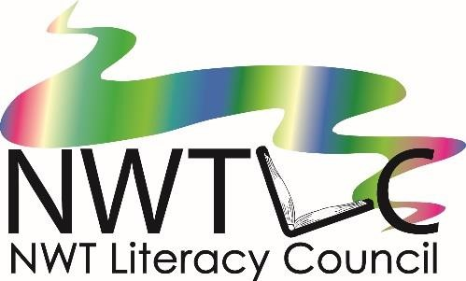
Family Literacy Training Institute
Days Inn, Yellowknife, NT
An annual training for Early Childhood Educators, Adult Educators, , Teachers, Educational Assistants, Community Health Representatives, Librarians Family Literacy Coordinators, and staff with preschool, Aboriginal Head Start, Canada Prenatal Nutrition Programs, or anyone interested in Family Literacy!

Workshop Overviews

Introduction to Family Literacy
The Introduction to Family Literacy workshop will explore the meaning of family literacy: how everyday activities such as cooking, making crafts and spending time together are literacy experiences for children. You will learn how to expand on these activities to incorporate them into your family literacy program.

Babies Are Born Learning
We now know that the brain grows more in the first three years of life than at any other time. This workshop explains the connection between early childhood experiences, brain development, and lifelong learning and well-being. It will cover the basics of early childhood brain development, how children learn language, and how parents and caregivers can give the early care needed to build a strong foundation for life.

1-2-3 Rhyme With Me
1-2-3 Rhyme with Me is a fun, interactive rhyming and singing program for young children and their parents. Come and learn how to facilitate this program in your community. You will learn about brain development and oral language development, as well as many fun rhymes and songs to use in your program. You will receive a book and a CD of rhymes, stories and songs to take home.

Choosing Books
The Choosing Books workshop will explore different types of books and why we love them! Participants will have the opportunity to share their favorite books with others. We will explore why different styles of books are best for different ages and stages. You will learn how to read with enthusiasm and have fun with reading. Get set for some fun, hands-on book exploration.

Family Literacy Nights
Family Literacy Nights are a great way to get started in family literacy in your community. This session will explore different ideas for family literacy nights, and ways you can partner with others in your community.

Storytime Adventures*
Storytime Adventures is a program for preschool children. Each session includes reading a story and doing a related craft, snack, game or other activity. After this workshop, you will be able to run a Storytime Adventures program in your community. You will receive a manual with ideas for 10 different Storytime Adventures to help you get started.

Bookmaking*
The bookmaking workshop will show you how to make books for your program (great for Indigenous languages) and also with participants in your program. You will learn how to make a variety of different books, using materials that are available in the NWT.

Science Fun*
Science Fun gives family literacy groups the information they need to carry out easy, fun, hands-on science activities for preschoolers. These experiments and activities introduce preschoolers to the world around them and help them develop positive attitudes towards science. After this workshop, you will be able to run a Science Fun program in your community

Little Chefs*
Little Chefs is a cooking program for family literacy groups. Preparing any recipe involves literacy. Any time you talk and do things with preschool children, you help them develop language skills. Older children may gain practice reading and writing recipes, following step-by-step instructions, weighing and measuring, and working with fractions. After this workshop, you will be able to run a Little Chefs program in your community.

*A different selection of these workshops is presented each year.

